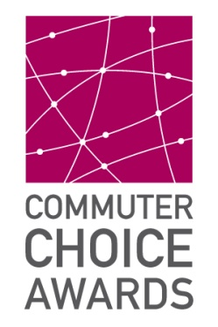

OFFICIAL NOMINATION FORM
All nomination materials must be emailed to awards@metrotransit.org by 4 p.m. on Friday, Aug. 30.
Directions
The 2013 Commuter Choice Awards nominations will only be accepted through electronic format. If you have any questions about this nomination form, please contact a Transportation Management Organization or Metro Transit. Contact information is on the last page of this form.
Eligibility
Employers, individuals or organizations must be located within the seven-county metropolitan area. Employers must actively encourage their employees to use transportation alternatives such as biking, walking, taking the bus or train, carpooling, vanpooling or teleworking. Organizations must actively encourage their students, tenants, community members or any other audience, other than employees, to use transportation alternatives such as biking, walking, taking the bus or train, carpooling, vanpooling or teleworking. Individuals must be able to demonstrate a commitment to promoting or advocating for transportation options in their workplace, school or community.
Awards recognize innovative outreach efforts or programs designed to increase the use of transportation alternatives such as biking, walking, taking the bus or train, carpooling, vanpooling or teleworking.
Judging panel and criteria
Nominations will be judged by a panel of Twin Cities transportation experts, commuter benefits coordinators, community leaders, and human resources, wellness and sustainability professionals. Judges will evaluate entries based on the documented efforts and success of promoting transportation options. The goal is to reward and recognize those actively contributing to the reduction of congestion and emissions in the Twin Cities area through alternative transportation initiatives.

Nominee
Please type in the blank boxes below.

I am a(n)
Building Owner/Management Company Government Entity Employer
Individual Organization

Please provide your name and organization name exactly as you want it to appear on news releases and other promotional materials.
Name Telephone
Employer or Organization Contact Email
Street Address
City State ZIP

Innovative Efforts
Please detail your nominee’s innovative efforts below. Judges will use this information in their evaluation. Limit your response to each question to approximately 200 words. You are encouraged to attach PDF versions of promotional materials, photographs and/or other supporting documents with this form. Please submit a form for each initiative to be considered.
What did you do?

Why did you do it?

How did you implement and promote it?

What were the results? Please be specific. For example, nominees should detail positive outcomes as they relate to environmental impact, communities served, participation rates, productivity, etc.

Closing Statement
Please tell the judges why this entry should win a Commuter Choice Award; include any details not listed above.

Consent authorization. If you are authorized to provide consent for the nominee please do so below. If you are not authorized to provide consent for your nominee, appropriate consent authorizations may be required.
I hereby authorize the use, in connection with the Commuter Choice Awards program, of my name, my company’s/organization’s name, non-financial information, photographs or video recordings of me from whatever source. I agree that no compensation shall be due me or my company for such usage.

By typing your name in this box you agree to the above terms.
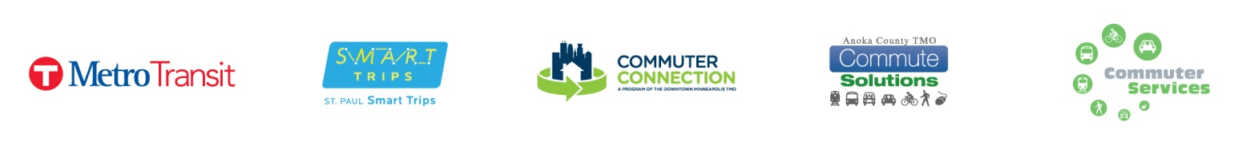
Signature or Typed Name Date

